Patient Safety Incident Response Framework Policy

Author and Contact details: | Sarah Craigie  Tel: (0151 556 4287)  Email: sarah.craigie@nhs.net
Responsible Director: | Chief Nurse
Approved by and date: | Quality Committee | July 2023
Document Type: | POLICY | Version 1.0
Target Audience: | All trust employees.
Document Approval, History/Changes | See Appendix 3  For further information contact the Governance Department on  Tel: (0151) 556 3082
Think of the environment…Do you have to print this out this document? You can always view the most up to date version electronically on the Trust intranet.

Contents
1. Purpose 3
2. Scope 3
3. Our patient safety culture 4
4. Patient Safety Partners 7
5. Addressing health inequalities 7
6. Engaging and involving patients, families and staff following a patient safety incident 8
7. Involving Staff, Colleagues and Partners 9
8. Patient safety incident response planning 9
9. Resources and training to support patient safety incident response 10
10. Our patient safety incident response plan 11
11. Reviewing our patient safety incident response policy and plan 11
12. Patient safety incident reporting arrangements 12
13. Patient safety incident response decision-making 13
14. Responding to cross-system incidents/issues 14
15. Timeframes for learning responses 14
16. Safety action development and monitoring improvement 14
17. Safety improvement plans for The Walton Centre 15
18. Oversight roles and responsibilities 15
19. Mortality Issues 16
20. Complaints and appeals 16
Appendix 1 – National Priority or Major Harm 17
Appendix 2 – Local Priority or Moderate Harm 19
Appendix 3 - Version Control 20
Appendix 4 Translation Service 21

1. Purpose
This policy supports the requirements of the Patient Safety Incident Response Framework (PSIRF) and sets out The Walton Centre NHS Foundation Trusts approach to developing and maintaining effective systems and processes for responding to patient safety incidents and issues for the purpose of learning and improving patient safety. It is important that all staff across the Trust understand the full range of incidents that should be reported, including near miss incidents, which allow the trust to proactively identify area for improvement. The PSIRF advocates a co-ordinated and data-driven response to patient safety incidents. It embeds patient safety incident response within a wider system of improvement and prompts a significant cultural shift towards systematic patient safety management.
This policy supports development and maintenance of an effective patient safety incident response system that integrates the four key aims of the PSIRF:
- compassionate engagement and involvement of those affected by patient safety incidents.
- application of a range of system-based approaches to learning from patient safety incidents
- considered and proportionate responses to patient safety incidents and safety issues
- supportive oversight focused on strengthening response system functioning and improvement.

The PSIRF sets no further national rules or thresholds to determine what method of response should be used to support learning and improvement. Instead, Trusts are now able to balance effort between learning through responding to incidents or exploring issues and improvement work.

Scope
This policy is specific to patient safety incident responses conducted solely for the purpose of learning and improvement across The Walton Centre NHS Foundation Trust. Any response that seeks to find liability, accountability or causality is beyond the scope of this policy.
Responses under this policy follow a systems-based approach. This recognises that patient safety is an emergent property of the healthcare system: that is, safety is provided by interactions between components and not from a single component. Responses do not take a ‘person-focused’ approach where the actions or inactions of people, or ‘human error’, are stated as the cause of an incident.
There is no remit to apportion blame or determine liability, preventability, or cause of death in a response conducted for the purpose of learning and improvement. Other processes exist for that purpose such as,
- claims handling,
- human resources investigations into employment concerns,
- professional standards investigations,
- Information governance concerns
- Estates and facilities concern.
- Financial investigations.
- Safeguarding concerns.
- complaints (except where a significant patient safety concern is highlighted).
- coronial inquests, and criminal investigations, exist for that purpose.
The principle aims of each of these responses differ from those of a patient safety response and are outside the scope of this policy.
Information from a patient safety response process can be shared with those leading other types of responses, but other processes should not influence the remit of a patient safety incident response.

Our patient safety culture
The Walton Centre NHS Foundation Trust promotes a just culture approach (in line with the NHS Just Culture Guide) to any work planned or underway to improve safety culture. Research into organisational safety has repeatedly found that an open and transparent culture, where colleagues feel able to report incidents and raise concerns without fear of recrimination, is essential to improving safety, ensuring staff are treated fairly and appropriately. Staff should never be left feeling isolated and uninformed about what will happen following a patient safety incident. The Walton Centre has a continuous learning culture and offers a wide range of learning and developmental opportunities, promoting a culture that encourages lifelong learning for all staff.

We want speaking up to improve the services we provide for patients and the environment our staff work in. Where it identifies improvements that can be made, we will ensure necessary changes are made, and are working effectively. Lessons will be shared with teams across the Trust, or more widely, as appropriate. Issues that have been raised will be discussed to ensure that we understand exactly what you are worried about. If we decide to investigate, we will tell you how long we expect the investigation to take and agree with you how to keep you up to date with its progress.

We want everyone in the Trust to feel safe to speak up and confident that it will be followed by a prompt response. Further information is provided in the “Freedom to Speak up Policy for the NHS” alongside additional policies including the “Disciplinary Policy” that sets out the process for managing employee conduct. All policies can be found on the staff Intranet.

All workers are required to complete the first module of Speaking up which is mandatory across the Trust.

People need to feel confident that if they call out poor behaviour, they will not experience detriment or retaliation. Creating and promoting psychologically safe spaces by promoting positive working relationships helps make staff feel secure, supported, and confident to speak up. Speaking up will ensure that as a Trust we have the right culture to hear staff concerns and recommendations for improvements, and to respond fairly and appropriately to those whistleblowing for patient safety in our organisation.

We support our managers/supervisors to listen to the issue raised and take action to resolve it wherever possible. In most cases, it’s important that this opportunity is fully explored, which may be with facilitated conversations and/or mediation. Where an investigation is needed, this will be objective and conducted by someone who is suitably independent (this might be someone outside our organisation or from a different part of the organisation) and trained in investigations. It will reach a conclusion within a reasonable timescale and a report will be produced that identifies any issues to prevent problems recurring.

The FTSU Guardian will review the concerns raised with the Executive and Non-Executive Leads for Raising Concerns to ascertain if there are themes. The FTSU Guardian submits data to the National Guardians Office each quarter who in turn reviews all submissions nationally to see if there are any themes locally or nationally. Our most senior leaders receive a report quarterly providing a thematic overview of speaking up by our staff to our FTSU guardian(s).

Good governance is essential, and we will ensure that all staff have easy access to information on how to speak up and that individuals will be referred to the national Speaking Up Support Scheme: https://www.england.nhs.uk/ourwork/freedom-to-speak-up/developing-freedom-to-speak-up-arrangements-in-the-nhs/staff . Further supporting documents include:

- Maintaining High Professional Standards Policy
- Guidelines for supporting staff involved in Traumatic/Stressful Incidents/Complaints or Claims
- NHS England Fit and Proper Person Test

The Trust encourages and supports incident reporting where any member of staff feels something has happened, or may happen, which has led to, or may lead to, harm to patients (or staff). Please refer to the “Incident Reporting Policy” for more information on how incidents are reported and managed in an open and transparent manner to focus on learning without blame. PSIRF will create much stronger links between a patient safety incident and learning and improvement. We will aim to work in partnership with those affected by a patient safety incident, staff, patients, families, and carers. Engagement is key.

We are clear that patient safety incident responses are conducted for the sole purpose of learning and identifying system improvements to reduce risk. Specifically, they are not to apportion blame, liability or define avoidability or cause of death.

To boost our safety culture, we have a daily Trust wide safety huddle for any member of staff at any level to attend and safety huddles at all levels of our Trust where any patient safety concerns can be raised and followed up. The safety huddle is then minuted and shared Trust wide via email. Departments have safety huddles in order to identify risks emerging or known and the insight offered from incidents that have occurred and therefore an opportunity to share any learning.
The flow chart below shows our internal governance process for escalation of issues to our Trust Board.

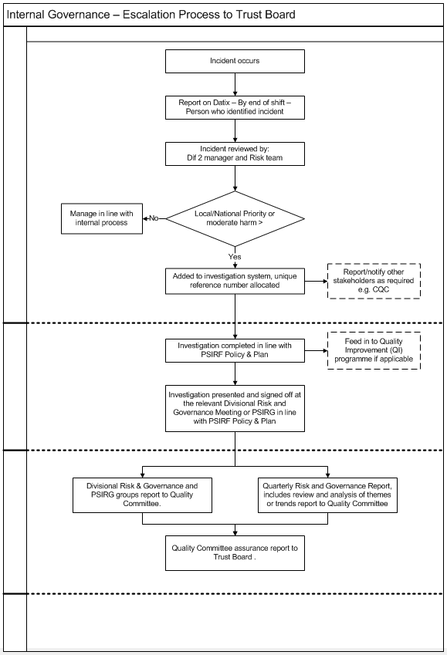

Patient Safety Partners
The Patient Safety Partner (PSP) is a new and evolving role developed by NHS England/ Improvement to help improve patient safety across the NHS in the UK. The introduction of PSPs should be considered the start of a journey that may significantly change the way the Trust approaches patient involvement. It requires power sharing, a commitment to openness and transparency between staff and patients, as well as good leadership; it must not be tokenistic.
The Walton Centre has successfully recruited three volunteer PSPs and we are very excited to have them work alongside our staff, patients, families/carers to influence and improve safety across the Trust.

PSPs will work alongside staff, volunteers, and patients, attend meetings (face-to-face and online), be involved in projects to co-design developments of patient safety initiatives, and join (and participate in) key conversations and meetings in the Trust focusing on patient safety. They will have a mind-set for improving outcomes, whilst representing the patient, carer, family view and ensuring committee/meeting members are “walking in the patients’ shoes”.
Please see the Framework for involving patients in patient safety guidance for further information.

https://www.england.nhs.uk/publication/patient-safety-incident-response-framework-and-supporting-guidance/#heading-2

Addressing health inequalities
As a specialist provider, the Trust has a key role to play in tackling health inequalities in partnership with our local partner agencies and services. Through the implementation of PSIRF, we will seek to utilise data gained from our incident reporting system and learning from investigations to identify actual and potential health inequalities and make recommendations to our Trust Board and partner agencies on how to tackle these. The more holistic, integrated approach to patient safety under PSIRF will require the Trust to be more collaborative with the patient experience and inclusivity agenda and ensure investigations and learning do not overlook these important aspects of the wider health and societal agenda.

Our engagement with patients, families and carers following a patient safety investigation must also recognise diverse needs and ensure inclusivity for all. Any potential inclusivity or diversity issues must always be identified through the investigation process and engagement with patients and families, for example, during the duty of candour / being open process.

The Walton Centre recognises that some groups of society can experience prejudice and discrimination. The Equality Act 2010 specifically recognises the protected characteristics of age, disability, sex, race, religion or belief, sexual orientation, transgender, pregnancy/maternity, and marriage/civil partnership. However, the Trust also acknowledges that other minority groups may also experience unfair treatment and discrimination.

When considering our safety actions in response to any incident we will consider if there are any inequalities, and this will be built into our governance and action planning process. We will use our reporting systems to monitor and identify any variations that identify any inequalities. By doing this we can identify any safety improvement work.

Engaging and involving patients, families and staff following a patient safety incident
The PSIRF recognises that learning and improvement following a patient safety incident can only be achieved if supportive systems and processes are in place. It supports the development of an effective patient safety incident response system that prioritises compassionate engagement and involvement of those affected by patient safety incidents (including patients, families, and staff). This involves working with those affected by patient safety incidents to understand and answer any questions they have in relation to the incident and signpost them to support as required.

Those affected by a patient safety incident may have a range of needs (including clinical needs) as a result and these must be met where possible. This is part of our duty of care. Meeting people’s needs not only helps alleviate the harm experienced, but also helps avoid compounding the harm. While we cannot change the fact that an incident has happened, it is always within our gift to compassionately engage with those affected, listen to, and answer their questions and try to meet their needs.

It is recognised from experience and research that patients and families often provide a unique, or different perspective to the circumstances around patient safety incidents, and / or may have different questions or needs to that of the Trust. Engaging with those affected by a patient safety incident substantially improves our understanding of what happened, and potentially how to prevent a similar incident in future.

Processes for engaging and involving those affected by patient safety incidents will be applied as follows:
- Apologies are meaningful. Apologising is a crucial part of the Duty of Candour.
- Approach is individualised.
- Timing is sensitive.
- Those affected are treated with respect and compassion.
- Guidance and clarity are provided. Patients, families, and healthcare staff can find the processes that follow a patient safety incident confusing.
- Those affected are ‘heard. Everyone affected by a patient safety incident should have the opportunity to be listened to and share their experience.
- Approach is collaborative and open.
- Subjectivity is accepted.
- Strive for equity.

This policy therefore reinforces existing guidance relating to the duty of candour and ‘being open’ and recognises the need to involve patients and families as soon as possible in all stages of any investigation, or improvement planning, unless they express a desire not to be involved.

Involving Staff, Colleagues and Partners
Involvement of staff and colleagues (including partner agencies) is of paramount importance when responding to a patient safety incident to ensure a holistic and inclusive approach from the outset. Again, this reinforces existing guidance such as our Incident Reporting policy, though it is recognised this approach must not be restricted to only those incidents that meet a threshold of harm or predefined categories. We will continue to promote, support, and encourage our colleagues and partners to report any incident or near-misses, with a shift in focus to incidents, or groups of incidents, which provide the greatest opportunities for learning and improvement.
We welcome speaking up as it is vital that our staff feel safe and are encouraged to speak up in order to raise their concerns to keep patients and staff safe to support the working environment for our staff. Anyone can speak up including health care professionals, non-clinical workers, receptionists, directors, managers, contractors, volunteers, students, trainee’s, junior doctors, locum doctors, bank and agency workers and former employees.

We encourage our staff to report concerns internally for us to act promptly as this is the quickest way for us to respond to incidents. However, you can report concerns externally to the Care Quality Committee (CQC) for quality and safety concerns about the services it regulates.

It is recognised that staff and colleagues need to continually feel supported to speak out and openly report incidents and concerns without fear of recrimination or blame. We will continue to closely monitor incident reporting levels and continue to promote an open and just culture to support this.
Our Trust will support staff on a day-to-day basis and ensure that staff have access to the right services to support staff through difficult and unexpected challenges.

Patient safety incident response planning
PSIRF supports Trusts to respond to incidents and safety issues in a way that maximises learning and improvement, rather than basing responses on arbitrary and subjective definitions of harm. Beyond nationally set requirements, organisations can explore patient safety incidents relevant to their context and the populations they serve rather than only those that meet a certain defined threshold.
By taking this approach we can focus our resources on incidents, or groups of incidents that provide the greatest opportunities for learning and improving patient safety. Planning needs to also consider other sources of feedback such as complaints, risks, legal claims, mortality reviews and other forms of feedback.
PSIRF guidance specifies the following standards that our plans should reflect:
- A thorough analysis of relevant organisational data
- Collaborative stakeholder engagement
- A clear rationale for the response to each identified patient safety incident type.
They will also be:
- Updated as required and in accordance with emerging intelligence and improvement efforts.
- Published on our external facing website.
Our associated patient safety incident response plan (PSIRP) will reflect these standards and will be published alongside this overarching policy framework.

Resources and training to support patient safety incident response.
PSIRF recognises that resources and capacity to investigate and learn effectively from patient safety incidents is finite. Our Trust has evaluated our capacity to deliver the plan. The Trusts PSIRF plan provides more detail in relation to the number of investigations that may be required for a single or small group of incidents that do not fall into one of the broader improvements workstreams.

The Trust will have in place governance arrangements to ensure that learning responses are not led by staff who were involved in the patient safety incident itself or by those who directly manage those staff. Learning responses are not taken in isolation. Subject matter experts with relevant knowledge and skills will be involved, where necessary, throughout the learning response process to provide expertise, advice, or proof reading.

The Trust has identified Patient Safety Specialists who have been designated to provide dynamic senior patient safety leadership. Furthermore, we have identified by reviewing patient safety staff who will have oversight roles, learning response leads and engagement leads.
From our data and incident analysis, as a Trust we estimate that we will complete approximately 5 Patient Safety Incident Investigation (PSII) reviews annually where national requirements have been met.

We aim to have a team of trained investigators who will be able to undertake investigations, but this will be in addition to their current substantive role and will require time to be allocated to complete their investigations. Our PSIRF plan gives further details into which incident will require a comprehensive investigation and how many we expect to complete in one year.

All Trust staff are required to complete mandatory Level 1 Patient Safety training which covers the basic requirements of reporting, investigating, and learning from incidents. This is a starting point for all our staff and includes and covers, listening to patients and raising concerns, the systems approach to safety, where instead of focusing on the performance of individual members of staff, we try to improve the way we work, avoiding inappropriate blame when things don’t go well, creating a just culture that prioritises safety and is open to learning about risk and safety.

Currently Band 6 (or equivalent) and above in Nursing and Midwifery, Registered Medical and Dental, and Allied Health Professionals are required to complete mandatory Level 2 Patient Safety training. Level 2 training is for clinical and non-clinical staff who have an interest in understanding more about patient safety or who want to go on to access the higher levels of training. This will be built upon as we review our plan and policy.

Learning responses will be led by staff who have completed at least a two-day formal training and skills development in learning from patient safety incidents and experience of patient safety incident response. Learning response leads will have completed level 1 (essentials of patient safety incidents) and level 2 training (access to practice). They will undertake continuous professional development in incident response skills and knowledge, and network with other leads at least annually to build and maintain their expertise. Learning response leads contribute to a minimum of two learning responses per year. Records of contributions will be kept by the Risk & Governance team.

Engagement leads will have completed level 1 and level 2 training and will have undertaken a minimum of 6 hours training relating to “Involving those affected by patient safety incidents in the learning process”.

Those in PSIRF oversight roles will have completed level 1 and level 2 training, a systems approach to learning from patient safety incidents equivalent to 2 days/12 hours training, oversight of learning from patient safety incidents which is equivalent to 6 hours training and involving those affected by patient safety incidents in the learning process, 6 hours of training.

Our patient safety incident response plan
Our plan sets out how The Walton Centre NHS Foundation Trust intends to respond to patient safety incidents. The plan is not a permanent set of rules that cannot be changed. We will remain flexible and consider the specific circumstances in which each patient safety incident occurred and the needs of those affected, as well as the plan.

The plan is based on a thorough analysis of themes and trends from all incidents over a 3-year period from 1st January 2020 to 31st Dec 2022. Data included all incidents, complaints and concerns, mortality reviews, legal claims, inquests, and risks. To plan response methods, we needed to examine patient safety incident records and safety data, describe safety issues demonstrated by the data, identify improvement work underway and agree response methods. Through stakeholder engagement, priorities identified in the plan will be regularly reviewed against quality governance reports and surveillance to ensure they are responsive to unforeseen or emerging risks.

11. Reviewing our patient safety incident response policy and plan
Our patient safety incident response plan is a ‘living document’ that will be appropriately amended and updated as we use it to respond to patient safety incidents. We will review the plan every 12 months to ensure our focus remains up to date; with ongoing improvement work our patient safety incident profile is likely to change. This will also provide an opportunity to re-engage with stakeholders to discuss and agree any changes made in the previous 12 months. We will continue with our PSIRF Task & Finish Group to maintain the engagement of our staff and share learning and gain feedback.

Updated plans will be published on our website, replacing the previous version.
A rigorous planning exercise will be undertaken every 12 months and more frequently if appropriate, as agreed with our integrated care board (ICB) to ensure efforts continue to be balanced between learning and improvement. This more in-depth review will include reviewing our response capacity, mapping our services, a wide review of Trust data (for example, patient safety incident investigation (PSII) reports, improvement plans, complaints, claims, staff survey results, inequalities data, and reporting data) and wider stakeholder engagement.

12. Patient safety incident reporting arrangements
All staff in our Trust are encouraged where possible to report all patient safety incidents on the Trusts local risk management systems (LRMS). The Walton Centre uses the Datix Incident Reporting System and will remain in line with the Trusts Incident Reporting Policy. The level of harm will also be recorded by the reporter. See the table below for definitions of harm. These reports will then be routinely uploaded to the national data base (Learning From Patient Safety Events-LFPSE) to support national learning. Locally, support is available on how to report an incident via the Trust intranet or with the Risk and Governance team.
Some incident types will require specific reporting and/or review processes to be followed. This is documented in our PSIRF Plan as well as the required response/action.
Daily review mechanisms are already established to ensure that patient safety incidents are responded to proportionately and in a timely manner. This will also consider the requirements for The Duty of Candour, as per The Duty of Candour Policy.
Most incidents will only require a local review within the service, however, if it is felt that there is an opportunity to learn from and improve, these should be escalated appropriately to the Divisions.
Levels of harm were previously set out in the National Reporting and Learning Service guidance on reporting patient safety incidents.
Level of harm
No harm (Impact prevented) | Any patient safety incident that had the potential to cause harm but was prevented, resulting in no harm to people receiving NHS-funded care. This may be locally termed a ‘near miss’.
No harm (impact not prevented) | Any patient safety incident that ran to completion, but no harm occurred to people receiving NHS funded care.
Minor harm | Any unexpected or unintended incident that required extra observation or minor treatment and caused minimal harm to one or more persons receiving NHS-funded care.
Moderate harm | Any unexpected or unintended incident that resulted in a moderate increase in treatment, possible surgical intervention, cancelling of treatment, or transfer to another area, and which caused significant but not permanent harm, to one or more persons receiving NHS-funded care.
Major harm | Any unexpected or unintended incident that appears to have resulted in permanent harm to one or more persons.
Death | Any unexpected or unintended incident that directly resulted in the death of one or more persons.

13. Patient safety incident response decision-making
The Trust will have arrangements in place to allow it to meet the requirements for review of patient safety incidents under PSIRF. Some incidents will require mandatory PSII, others will require review by, or referral to another body or team depending on the event. These are set out in our Patient Safety Incident Response Plan.
To improve safety and manage risk within our Trust it is important that all events from which learning can be extracted are identified and managed with this framework to support improvement.
As a Trust we will need to at times respond to cross system patient safety incidents. We will forward those incidents identified as presenting potential significant learning and improvement to the other provider directly via their organisations Patient Safety Team or equivalent. Reporting can then be shared to provide insight. The Trust will work with the partner provider and Integrated Care Board (ICB) to ensure that the process does not delay information sharing and learning. This will enable us to learn together and improve patient safety.
The process for reporting incidents will not change and the decision-making process can be seen in the flow charts (Appendix 1 & Appendix 2). Our Trust has a weekly safety meeting where the responsibility will be for the review of investigations relating to local priorities or moderate harm incidents and the consideration of incidents for PSII or PSR and for an oversight of the outcomes to ensure that any recommendations are established in a system-based approach and safety actions are completed with Divisional representation. The newly formed Patient Safety Incident Response Group (PSIRG) will be responsible for:
- Identifying the Lead investigator
- Establish a team
- Setting Terms of Reference
- Allocate tasks
- Agree timescales and reviews-
- Patient Safety Incident Investigation (PSII) to be completed using PSII template. Recommendations added to Investigation system for tracking.
Divisions will monitor the QI programmes for local priorities. This gives the Board assurance that as a Trust we are complying with the PSIRF response standards.

14.Responding to cross-system incidents/issues
If more than one organisation is involved in the care and service delivery in which a patient safety incident has occurred, the organisation that identifies the incident is responsible for recognising the need to alert relevant stakeholders to initiate discussions about subsequent investigation and actions. All relevant stakeholders involved should work together to undertake one single investigation wherever this is possible and appropriate. The integrated care system should help to facilitate discussions relating to who is the most appropriate organisation to take responsibility for co-ordinating the investigation process.

Timeframes for learning responses
Where a PSII is indicated, the investigation will commence as soon as possible after the event. The Trust will aim to complete all National Priority or Major Harm PSII’s within 60 working days. The Trust will aim to complete investigations for Local Priority or Moderate Harm incidents using the appropriate templates within 10 working days. Timeframes for the completion of PSIIs will be agreed with those affected, as part of the terms of reference, as long as they are wanting to be involved.
Where external bodies (or those affected by patient safety incidents) cannot provide information, to enable completion within six months or the agreed timeframe, the PSII leads should work with all the information they have to complete the response to the best of their ability; it may be revisited later should new information indicate the need for further investigative activity.
In some incidences, longer timeframes may be required for completion of the PSII. In this case, any extended timeframe should be agreed between the Trust and those affected.

Safety action development and monitoring improvement
Recognising that the first step when embarking on a process to learn and improve after a patient safety incident is to make efforts to understand the context and develop a deep understanding of work processes. It is important to understand “work as done” and the systems factors that influence work. Areas for improvement can relate to a specific local context or to the context of the wider organisation. Findings from PSIIs and PSRs provide key insights and learning opportunities, but they are not the end of the story. PSIRF moves away from the identification of ‘recommendations’ which may lead to solutions at an early stage of the safety action development process.
By identifying and agreeing aspects of the work system where change could reduce risk and potential for harm (ie ‘areas for improvement’ or system issues). Actions to reduce risk (ie safety actions) are then generated in relation to each defined area for improvement. Following this, measures to monitor safety actions and the review steps are defined.
Processes for safety action development are outlined by NHS England in the Safety Action Development Guide (2022) as below:
- Agree areas of improvement-Specify where improvement is needed without defining how that improvement is to be achieved.
- Define context-Agree approaches to developing safety actions by defining context.
- Define safety actions to address areas of improvement-continue to involve the team-make this a collaborative process, focus on the system.
- Prioritise safety actions -avoid prioritising actions based on intuition/opinion alone.
- Define safety measures-identify what can be measured to determine whether the safety action is influencing what is intended. Prioritise safety measures. Define measures and who is responsible for collecting, analysing, reporting, and acting on the data.
- Write safety actions-document in a safety improvement plan including details of measurement and monitoring.
- Monitor and review.
A Quality Improvement approach is valuable in this aspect of learning and improvement following a patient safety investigation. It will therefore be necessary to ensure close links are developed and maintained with the Transformational Team so their expertise and guidance can be utilised when developing the learning response and safety actions.
Safety actions arising from a learning response should follow the SMART (Specific, Measurable, Achievable, Realistic, Time-bound) principles and thought must be given to monitoring and measures of success. Further guidance on this can be found in NHSE Guidance at:
https://www.england.nhs.uk/wp-content/uploads/2022/08/B1465-Safety-action-development-v1.1.pdf.
Safety actions will continue to be monitored through the governance processes with oversight at Quality committee.

Safety improvement plans for The Walton Centre
As referred to throughout the policy, the Trust has developed a Patient Safety Incident Response Plan (PSIRP) that clarifies what our improvement priorities are. The PSIRP details how we will ensure patient safety incidents are investigated in a more holistic and inclusive way, to identify learning and safety actions which will reduce risk and improve safety and quality.
The Trust has several overarching safety improvement plans already in place including individual safety improvement plans that focus on specific services. Where overarching system issues are identified by learning responses outside of the Trust local priorities, a safety improvement plan may be developed. These will be identified through the Weekly Safety Meeting and the Patient Safety Incident Review Group (PSIRG) and Divisional Risk and Governance Groups. Monitoring of progress will be overseen by the Quality and Patient Safety Group, in turn reporting to Quality committee.

Oversight roles and responsibilities
NHSE, PSIRF Guidance ‘Oversight roles and responsibilities specification and Patient safety incident response standards’ (p2)
Responsibility for oversight of the PSIRF for provider organisations sits with the Trust Board. The Board through the Executive Medical Director and Chief Nurse have devolved responsibility to the Deputy Medical Director and the Deputy Chief Nurse who hold joint responsibility for effective monitoring and oversight of PSIRF. The ‘Responding to patient safety incidents’ section above also describes some of the more operational principles that underpin this approach. It is important that under PSIRF there is a paradigm shift from monitoring of process, timescales and outputs to meaningful measures of improvement, quality and safety, and outcomes for patients. It should be noted that similarly the ICB’s role will focus on oversight of PSIRF plans / priorities and monitoring progress with improvements. There will no longer be a requirement to ‘declare’ an SI and have individual patient safety responses ‘signed off’ by commissioners. However, they will wish to seek assurances that improvements and priorities under PSIRF are progressing and delivering improvements in quality and safety. The metrics, measures (objective and subjective) and evidence required to do this will need to be defined within the PSIRP for each priority which will be agreed in discussion with the ICB.

Mortality Issues
Our Trust has established a monthly Mortality Surveillance Group in 2022/23 to provide oversight of compliance with the mortality review process and will provide the Trust with the assurance that causes, and contributory factors of patient deaths have been considered and are appropriately responded to in an open and transparent manner.
Under PSIRF, not all deaths reviewed by a coroner will be subject to a full Patient Safety Incident Investigation (PSII). Under the new Framework, the learning response within the NHS should not be expected to make judgments about cause of death. If a PSII is undertaken regarding a death that will be reviewed by a coroner, the coroner will receive the PSII report. If a different learning response is undertaken, the output from the response will be shared with the coroner.
As we have said, not all deaths reviewed by a coroner will receive a full patient safety incident investigation (PSII). In some cases, there will be a different learning response such as a case review, MDT, Swarm Huddle or an After-Action Review. The output from that response will be shared with the coroner.

Complaints and appeals
Any complaints relating to this policy, or its implementation can be raised informally with the Trust Risk & Governance team, initially, who will aim to resolve any concerns as appropriate.
Formal complaints from patients or families can be lodged through the Trust’s complaints procedure. At the earliest opportunity speak to the manager of the ward, matron, department, or doctor in charge of your care to let them know what you are not happy with. They will do all they can to resolve the issues that you raise.
You can also contact the Patient Experience Team on: 0151 556 3090, 3091 or 3093 Monday - Friday between 9.00 am - 4.00 pm or email at: wcft.patientexperienceteam@nhs.net
Alternatively, you may wish to write directly to our Chief Executive:
Chief Executive
The Walton Centre NHS Foundation Trust
Lower Lane
Liverpool
L9 7LJ
We will do our utmost to resolve your complaint but if you remain unhappy you can refer your complaint to the Parliamentary Health Service Ombudsman (PHSO), which is the second and final stage of the NHS complaints procedure.
The PHSO is completely independent of the NHS and government. They make the final decision on complaints that have not been resolved by the NHS.
You can contact them by calling their Customer Helpline on 0345 015 4033, visit their website at www.ombudsman.org.uk or write to them directly:
Parliamentary Health Service Ombudsman
Millbank Tower
Millbank
London
SW1P 4QP

Appendix 1 – National Priority or Major Harm

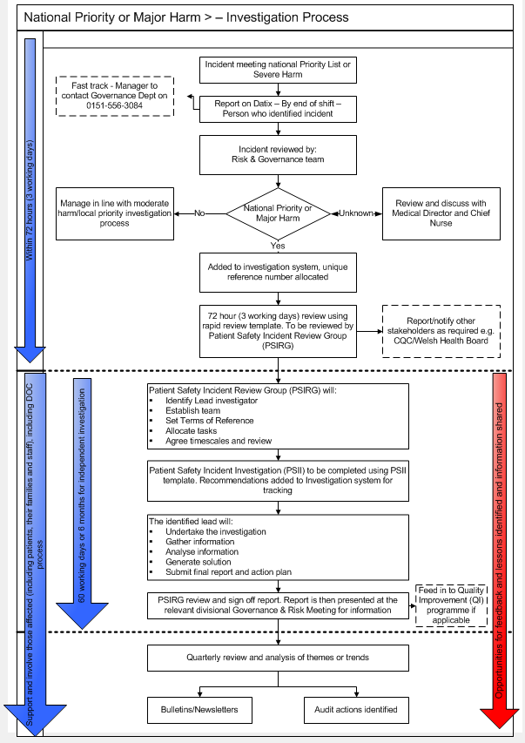

Appendix 2 – Local Priority or Moderate Harm

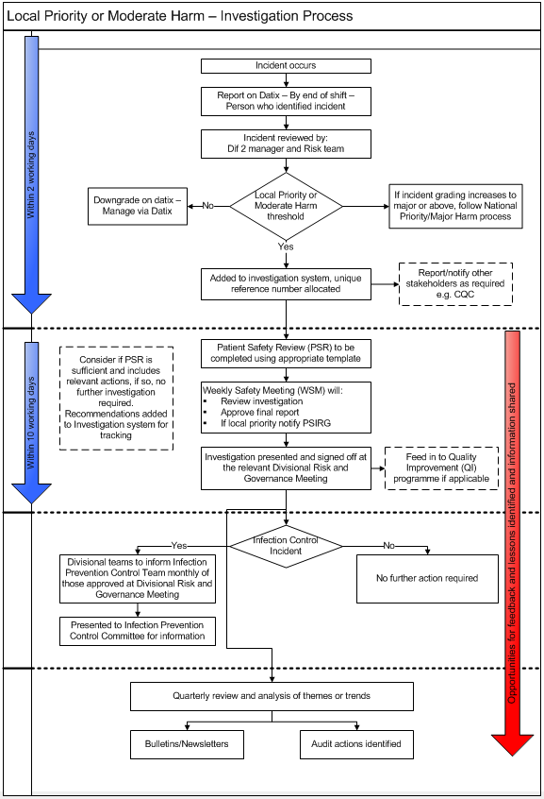

Appendix 3 - Version Control
Version | Section/Para/  Appendix | Version/description of amendments | Date | Author/Amended by
1 | All | New policy development | 13/07/2023 | Sarah Craigie

Appendix 4 Translation Service
If you require this leaflet in any other language or format, please contact the Patient Experience Team on 0151 556 3091 or 3093, or email wcft.patientexperienceteam@nhs.net stating the leaflet name, code and format you require.

Arabic | اذا كنت بحاجة إلى هذه النشرة بأي لغة أو تنسيق آخر، فيرجى الاتصال بفريق متابعة تجارب المرضى على الرقم  0151 556 3091 أو 3093، أو إرسال بريد إلكتروني إلى wcft.patientexperienceteam@nhs.net موضحاً اسم النشرة، والرمز، والشكل الذي تطلبه.
Chinese | 如果你想索取本传单的任何其他语言或格式版本，请致电0151 556 3091或3093联络「病人经历组」，或发电邮至wcft.patientexperienceteam@nhs.net，说明所需要的传单名称、代码和格式。
Farsi | در صورت نیاز به این بروشور به هرفرم یا زبان دیگری,لطفا با تیم تجربه بیمار با شماره ۰۱۵۱۵۵۶۳۰۹۱  wcft.patientexperienceteam@nhs.net یا۳۰۹۳ یا با ایمیل زیرتماس بگیرد  با ذکر نام بروشور ، کد و قالب مورد نیاز خود
French | Si vous avez besoin de ce dépliant dans une autre langue ou un autre format, veuillez contacter Patient Experience Team (équipe de l’expérience des patients) au 0151 556 3091 ou 3093, ou envoyez un e-mail à wcft.patientexperienceteam@nhs.net en indiquant le nom du dépliant, le code et le format que vous désirez.
Polish | Jeśli niniejsza ulotka potrzebna jest w innym języku lub formacie, należy skontaktować się z zespołem ds. opieki nad pacjentem (Patient Experience Team) pod numerem telefonu 0151 556 3091 lub 3093, lub wysłać wiadomość e-mail na adres wcft.patientexperienceteam@nhs.net, podając nazwę ulotki, jej kod i wymagany format.
Punjabi | ਜੇ ਤੁਹਾਨੂੰ ਇਹ ਕਿਤਾਬਚਾ ਕਿਸੇ ਹੋਰ ਭਾਸ਼ਾ ਜਾਂ ਫਾਰਮੈਟ ਵਿੱਚ ਚਾਹੀਦਾ ਹੈ, ਤਾਂ ਕਿਰਪਾ ਕਰਕੇ ਪੇਸ਼ੇਂਟ ਐਕਸਪੀਰਿਅੰਸ ਟੀਮ ਨਾਲ 0151 556 3091 ਜਾਂ 3093 'ਤੇ ਸੰਪਰਕ ਕਰੋ, ਜਾਂ wcft.patientexperienceteam@nhs.net 'ਤੇ ਈਮੇਲ ਕਰੋ ਅਤੇ ਪਰਚੇ ਦਾ ਨਾਮ, ਕੋਡ ਅਤੇ ਆਪਣਾ ਲੋੜੀਂਦਾ ਫਾਰਮੈਟ ਦੱਸੋ।
Somali | Haddii aad u baahan tahay buug-yarahan oo luqad kale ku qoran ama isaga oo qaab kale ah, fadlan Kooxda Waayo-arragnimada Bukaanka kala soo xiriir 0151 556 3091 ama 3093, ama email-ka wcft.patientexperienceteam@nhs.net oo sheeg magaca iyo summadda buug-yaraha iyo qaabka aad u rabtid.
Urdu | اگر آپ کو یہ کتابچہ کسی دیگر زبان یا شکل میں درکار ہو تو، براہ کرم پیشنٹ ایکسپیریئنس ٹیم سے 0151 556 3091 یا 3093 پر رابطہ کریں، یا کتابچے کا نام، کوڈ اور اپنی مطلوبہ شکل کا ذکر کرتے ہوئے wcft.patientexperienceteam@nhs.net پر ای میل کریں۔
Welsh | Pe byddech angen y daflen hon mewn unrhyw iaith neu fformat arall, byddwch cystal â chysylltu gyda’r Tîm Profiadau Cleifion ar 0151 556 3091 neu 3093, neu ebostiwch wcft.patientexperienceteam@nhs.net gan nodi enw’r daflen, y cod a’r fformat sydd ei angen arnoch.

